ECE3093 Optimisation Estimation and Numerical Methods Part 1

1. Introduction and Matrix LU Decomposition

1.1Gaussian Elimination Review

1.1.1 Steps
[U|c] is upper triangular, so we need to create zeroes below the pivots of the augmented matrix:

Pivot is the first non-zero element in a row

1.1.2 Example
1) Augmented Matrix
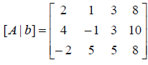
2) Row operations
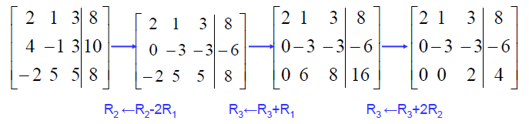
The order of elimination：
First, get the first column all zero (except for R1)
Secondly, get the second column all zero (except for R1 and R2)
… and so on

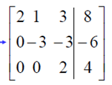
This is called row echelon form or row canonical form denoted by [U|c] (Upper-triangular | constant)

3) Back Substitution

1.2 Elementary matrices
If an identity matrix has undergone one elementary operation, than it becomes an elementary matrix

1.2.1 Elementary operation
Row switching (inverse: its own; NOT switching back)
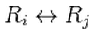
Row multiplying (inverse: division)
Row addition (inverse: subtraction)
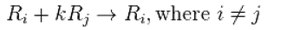

1.2.2 Inverse of elementary matrices
The inverse elementary matrix E⁻¹, is quickly obtained by applying the inverse elementary operation to the identity matrix

Example
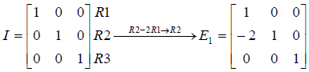
The inverse of R2 – 2R1 -> R2 is R2 + 2R1 ->R2
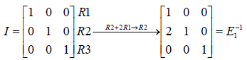

1.2.3 Property
A matrix M left-multiplied by an elementary matrix E produces the same row operations on the rows of M

Example
A=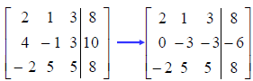=B
E₁ * A = B

1.3 Decomposing A=LU
A factorization of a square matrix A as A=LU, where L is lower triangular and U is upper triangular, is called LU decomposition or factorization

Example
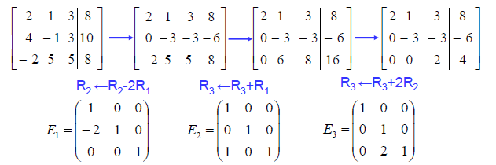
Using the property
So
By properties:
- The product of lower triangular matrices is also lower triangular
- The inverses of lower triangular matrices are also lower triangular
So, L is lower triangular

Note: A=LU only exists if A can be reduced to echelon form without elementary operations that swap rows (otherwise E may not be lower triangular)

1.4 Permutation matrices
The permutation matrices (P) is used to include the swap rows operation in decomposition

Example
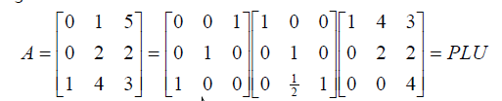
The P here represents swapped rows 1 and 3

The order that P is always on the left is due to the fact that in Gaussian eliminations, swapping rows is always the first elementary operation to be done.

2. Review: Vectors, matrices, linear systems

2.1 Vector notations
An vector can be notated as a column matrix

A vector x = (x₁, x₂, x₃) is really represented as a linear combination of the unit vectors e₁, e₂, e₃of standard coordinates
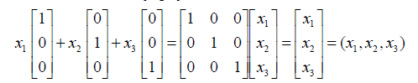
However, the vectors can be any coordinates axes

2.2 Vector products
Inner (dot) product

Outer product
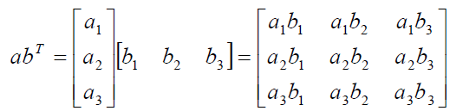

The echelon form of this matrix reveals that rank of (ab^{T}) is 1
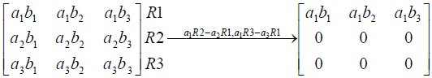

2.3 Matrix products
For the product AB to exist: the number of columns of A must equal the number of rows of B so that the inner product can be calculated

If AB=C, then each element c_{ij} of C is calculated as
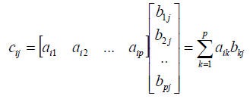
i^{th} row of A multiply j_{th} row of B respectively and add the products together

Matrix-vector multiplication (3 methods)
Row method
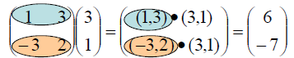
Column method
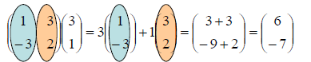

Expansion of matrix-vector product as sum of outer products

Linear combinations of vectors
The vector v is a linear combination of the vectors v₁, ..., v_{k} if
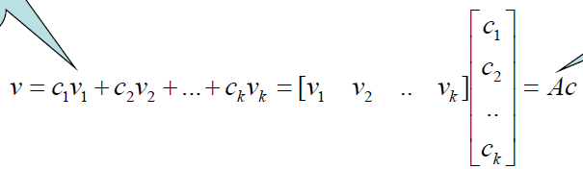

2.4 Linear dependency
A set of vector is linearly independent if
A set of vector is linearly dependent if at least one of them is a linear combination of the others

Example
(1, 0, 0) *2 = (2, 0, 0) so they are linearly dependent; but (2, 0, 0) and (0, 2, 0) are not.

Condition of linear independence
The condition for linear independence is that there is no solution to$Vc=0$apart from trivial $c=0$(V = [v1, v2, v3 …]) (determinant of V is non-zero or using row echelon form to find the solution)

Free Variables
A variable is a basic variable if it corresponds to a pivot column in echelon form. Otherwise, the variable is known as a free variable.

Example
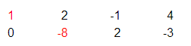
The first and second columns are pivot columns, so variables x1 and x2 are basic variables. The third column is not a pivot column, so x3 is a free variable.

2.5 Mapping
Mapping a point x to a new location based on A
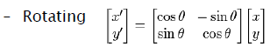
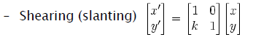

A defines a new coordinate system.
Effect | Matrix A
Rotating | orthonormal
Scaling | diagonal
Reflecting | (-1,0;0,1) across y; (1,0;0,-1) across x;
Shearing | triangular

Solving Ax=b is really asking us to find the coefficients of the columns of A that are added linearly to get b

Hanger and Aligner matrix
Applying a hanger matrix takes a vector in standard coordinates and “hangs” it on the new coordinate system
Applying an aligner matrix takes our new coordinate system and aligns it back to the standard e1, e2, e3
$$A_{hanger}={A_{alligner}}^{T}$$

2.6 Ax=b as a change of coordinates (basis)
The columns in A can be regarded as non-standard basis comparing to standard basis matrix I.

Example
$$Ax=b$$
$$\left[\begin{matrix}1 & 2 & 0 \\ 0 & 1 & 3 \\ 2 & 0 & 2\end{matrix}\right]\left[\begin{matrix}1 \\ 2 \\ 3\end{matrix}\right]=\left[\begin{matrix}5 \\ 11 \\ 8\end{matrix}\right]=\left[\begin{matrix}1 & 0 & 0 \\ 0 & 1 & 0 \\ 0 & 0 & 1\end{matrix}\right]\left[\begin{matrix}5 \\ 11 \\ 8\end{matrix}\right]$$
The elements in x are the coefficients to the non-standard basis.
$$1*\left[\begin{matrix}1 \\ 0 \\ 2\end{matrix}\right]+2*\left[\begin{matrix}2 \\ 1 \\ 0\end{matrix}\right]+3*\left[\begin{matrix}0 \\ 3 \\ 2\end{matrix}\right]=5*\left[\begin{matrix}1 \\ 0 \\ 0\end{matrix}\right]+11*\left[\begin{matrix}0 \\ 1 \\ 0\end{matrix}\right]+8*\left[\begin{matrix}0 \\ 0 \\ 1\end{matrix}\right]$$

The coefficients (x) correspond to points on the standard coordinate system. In this way, the points have been transformed into a non-standard coordinate system (A). The results are moves of points on the standard coordinate system (b).

2.7 Matrix Rules
$${(AB)}^{T}=B^{T}A^{T}$$
$${(AB)}^{-1}=B^{-1}A^{-1}$$
$${(A+B)}^{T}=A^{T}+B^{T}$$

3. Matrix operations and properties

3.1 Zero Matrix
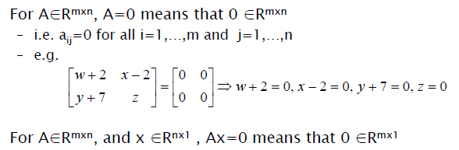

3.2 Identity Matrix
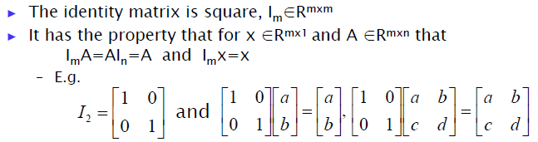

3.3 Diagonal Matrix
Diagonal matrices are always square and only diagonal elements can be non-zero.

Properties
1) Pre-multiplying a matrix by a diagonal matrix scales the rows of the matrix.
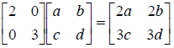

2) Post-multiplying a matrix by a diagonal matrix scales the columns of the matrix
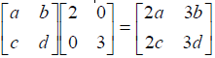

3) If the diagonal elements are all non-zero, a diagonal matrix is invertible and is simply inverting every elements

4) The product of compatible diagonal matrix is also diagonal
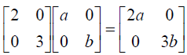

5) Their eigenvalues are their diagonal entries

A tri-diagonal matrix has two more diagonals (a sub-diagonal and a super-diagonal)
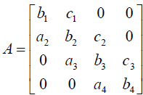

3.4 Upper and Lower Triangular Matrices
- Their eigenvalues are their diagonal entries

- Standard operations (sum, product, inverse) on triangular matrices preserve the triangular form

3.5 Symmetric matrices
A symmetric matrix A is necessarily square with A=A^{T}
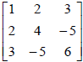

A skew-symmetric matrix has A=-A^{T} (diagonal entries must be zeros)
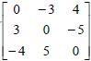

3.6 Complex Matrices
Complex Matrix
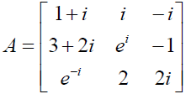

Conjugate Matrix
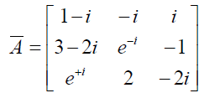

The transpose of the conjugate matrix A^{H} is called “A Hermitian”
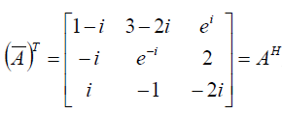
If$A=A^{H}$, then A is called a Hermitian matrix

3.7 Orthonormal matrix
A orthonormal matrix is A square matrix that
-Orthogonal: The dot product of the column vectors is zero
- Normalized: All columns of A are unit vectors (has a length of 1)

Example
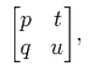is a orthonormal matrix if 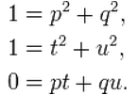

Property: $A^{-1}=A^{T}$ for orthonormal matrices

3.8 Other Special Matrices
A Toeplitz matrix has constant diagonal
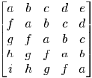

The entries of a stochastic matrix, P, are probabilities 0<p_{ij}<1. The rows and/or columns sum to unity.
(row stochastic)

3.9 Block Structure
Partitioning a matrix into blocks or sub-matrices can ease calculations

Example
Note that the blocks do not have to be in the same dimension.

3.9.1 Block diagonal matrices

Example

3.9.2 Kronecker product

Example

3.10 Determinants

3.10.1 Definition and meaning
The determinant of a matrix A (denoted as det(A) or |A|) is a special number associated with any (and only) square matrix
The fundamental geometric meaning of a determinant is a scale factor when the matrix is regarded as a linear transformation.

A square matrix has an inverse, A⁻¹, if and only if its determinant is non-zero. (Geometrically, determinant=0 means the scale factor is zero, which creates a null, and the inverse process from a null does not exist.)

3.10.2Properties
- If a square matrix is not full ranked, then det=0.
- Swapping two rows or two columns changes the sign of the determinant
- If a square matrix is triangular then its determinant is equal to the product of its diagonal elements

3.10.3 Applications
- Determine the existence of inverse
- Cramer’s rule
- Find eigenvalues det(A-xI)

3.11 Rank
Rank(A) is the maximum number of linearly independent rows (or columns) of A. In echelon form, the number of non-zero rows is the rank.
It can be calculated as the number of pivot rows of A in row echelon form U, so that rank(A)=rank(U)

Full rank
$$rank\left(A\right)=min⁡(m,n)$$

 | det (A) | Inverse A | Full Rank | Solutions | Linear Independency
Ax = 0 | 0 | Not exist | No | Infinitely many | No
 | non-zero | Exist | Yes | X = 0 | Yes
Ax = b | 0 | Not exist | No | No solution or infinitely many | No
 | non-zero | exist | Yes | Unique solutions | Yes

- A non-invertible matrix is also called singular matrix
- If a system has a solution, it is consistent; no solution, inconsistent

4. Eigen analysis

4.1 Significance of Eigenvectors
A matrix may act on certain vectors by changing only their magnitude and leaving their direction unchanged (or reversing it):
- These vectors are the eigenvectors of the matrix
- The scaling factor for the new magnitude of the eigenvector is the eigenvalue
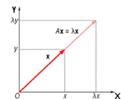

Gaussian elimination and LU decomposition do not preserve eigenvalues

4.2 Find Eigenvalues and Eigenvectors
Solve for$λ$
$$det\left(A-λI\right)=0$$
det(A-λI)=0 guarantees that the homogeneous system $\left(A-λI\right)x=0$has infinitely many solutions
Substitute the eigenvalue$λ$to the equation$\left(A-λI\right)x=0$, and solve for x (using Gauss’s elimination)
Note that x cannot be zero vectors

Checking Answers using properties
a) The sum of the eigenvalues of A is equal to the sum of the elements of the diagonal of A (Trace(A))

b) The product of the eigenvalues of A is equal to the determinant of A

4.3 Real symmetric matrices
Real symmetric matrices A (n*n) have
- Only real eigenvalues;
- n distinct linearly independent (thus, invertible) eigenvectors; (not n distinct eigenvalue)
- The eigenvectors are pairwise orthogonal and form an orthogonal basis.
- Not necessarily invertible

4.3.1 Diagonalisation of A
Any real symmetric matrix has a decomposition of the form
$$A=QDQ^{T}$$
where D is a diagonal matrix with the eigenvalues of A on the diagonal and Q is a matrix of eigenvectors of A in its columns

4.4 Examples on how Eigenanalysis eases computations
Power
We can express any vector y as a combination of the eigenvectors x

Let y=(7, -1) and eigenvectors (1, -1) and (1, 2) corresponding to eigenvalues 6 and 3
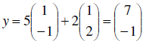
So with $Ax=λx$

Inverse A⁻¹x
When inverse of A is multiplied by an eigenvector, it is the same as scaling the eigenvector by the inverse of the correspond eigenvalue

Let x be an eigenvector corresponds to eigenvalue 6, so Ax=6x
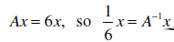

5. Diagonalisation and its applications

5.1 Diagonalisation
We can express any vector y as $y=Xc$ with X being eigenvectors of square matrix A.
Therefore
$$Ay=AXc=A\left(c_{1}x_{1}+c_{2}x_{2}+…c_{n}x_{n}\right)$$
$$=\left[x_{1}x_{2}…\right]\left[\begin{matrix}λ_{1} & 0 & 0 \\ 0 & λ_{2} & 0 \\ 0 & 0 & …\end{matrix}\right]\left[\begin{matrix}c_{1} \\ c_{2} \\ …\end{matrix}\right]=XDc=XDX^{-1}y$$
So
$$A=XΛX^{-1}$$
Conditions
- A is square
- X inverse exists => GM=AM (A is non-defective)
A can be decomposed into a diagonal matrix with eigenvalues and eigenvector matrices
This is known as the diagonalisation

5.2 Diagonalisation of real symmetric A
For real symmetric A, its eigenvectors are pairwise orthogonal. If we normalise these eigenvectors, they become orthonormal and we denote by the matrix Q. The normalisation eliminates the need for calculating inverse.

For a orthonormal matrix,$Q^{-1}=Q^{T}$, so A can be decomposed as
$$A=QΛQ^{T}$$
and it is applicable if A is symmetric.

Spectrum decomposition
If a matrix has an orthogonal basis of eigenvectors (n linearly independent eigenvectors) then a diagonalisation exists as
$$A=QΛQ^{T}$$
A being symmetric is a case of spectrum decomposition

5.3 Geographic significance of diagonalisation
- $Q^{T}$rotates the figure by $α$
- $Λ$ stretches the figure.
- $Q$rotates the figure by $α$ in a reverse direction
So $QΛQ^{T}$ does rotation-stretch-rotation (back)
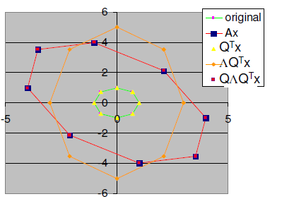

5.5 Spectral Decomposition’s benefits
Calculate powers of A
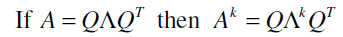
Example
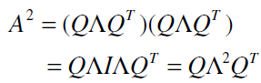(as Q⁻¹=Q^{T})
Powers of a diagonal matrix is calculated by power of all the diagonal elements

Calculation of A⁻¹
It follows the power of A
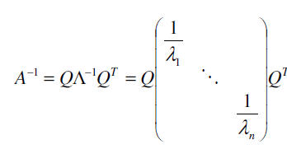

5.5 The Principal Axes Theorem
Every quadratic form can be diagonalised
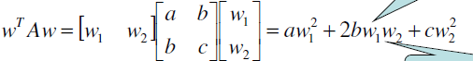
A is symmetric, so we can apply spectral theorem and$A=QΛQ^{T}$. Then we diagonalise A
(y=Q^{T}w)
y gives the coordinates of w by w=Qy. In this way, the cross product term w1w2 is eliminated

Example
For
using the principal axes theorem we have
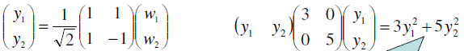

5.6 Applications of Diagonalisation
Power of a matrix A
$$A^{n}=XΛ^{n}X^{-1}$$

Exponential of a Diagonal Matrix
If the matrix A can be diagonalised into $A=QΛQ^{T}$
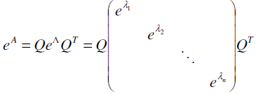

Systems of DE’s (not examinable)
Example
Solve
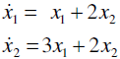
Solution
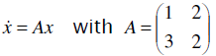
Diagonalisation yields
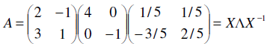
then
=> =>

6. Applications to Principal Component Analysis
Principal Component Analysis (PCA)
PCA creates a reduced matrix that retains most of the useful information and discards the noise

6.1 Covariance
If data is stored in matrix X with N observations in rows and m features/variables in columns, the covariance of the matrix X is calculated by
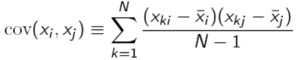
with the mean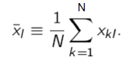
The covariance measures how two features change together.

6.2 Covariance Matrix
All the covariance form a matrix C, which can be calculated
where$\tilde{X}=[\tilde{X_{1}}…\tilde{X_{j}}]$ is called the normalised data vector
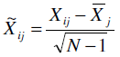(column vector elements subtract by its mean)

Example
For a matrix with two column vectors H and M
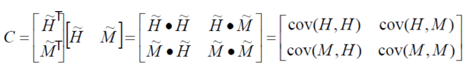
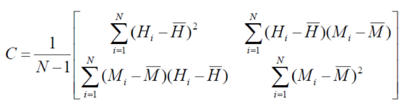
In general, $cov \left(H,M\right)=cov(M,H)$; $cov \left(H,H\right)=var(H)$

Also note that the covariance matrix C is always symmetric.

6.3 Covariance Decomposition
The symmetric covariance matrix C can be decomposed by
$$C=XX^{T}=VΛV^{T}$$
Usually, there is dominant eigenvalues in $Λ$. So we can approximate C by them
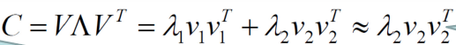

6.4 Projection onto Principal Axes
We can use the eigenvector matrix V to change base and project the normalised data in the direction of the eigenvectors (either all of them, or just the dominant ones = principal axes)

- Projection $\hat{W }$is achieved by right multiplying the normalised data X by Vk
$$\hat{W}=\tilde{X}V_{k}$$
$V_{k}$ is the k principle axes (eigenvectors) we choose.

Kaiser criterion suggests all $λ>1$ should be principle axes

Derivation: rotating (projection)
Column data to new column axes
Any normalised column vector $\tilde{x}$ can be expressed as a linear combination of the columns of orthonormal eigenvector V
In similar sense, any matrix of observations (in columns) can be expressed as a linear combination of the eigenvectors
Row data to new row axes
We have a normalised row vector$\tilde{x}$. The transpose${\tilde{x}}^{T}$is a column vector can be expressed as a linear combination of the columns of orthonormal eigenvector V

6.5 Reverse Transformation
We then convert the projected data back to standard coordinate system
$W=\hat{W}\sqrt{N-1}+μ$
The new data are leaner and with less noise.

6.6 PCA Summary
- Raw data X (N*m) is mean-centred and normalised $\tilde{X}$
- The covariance matrix C (m*m) is calculated by ${\tilde{X}}^{T}\tilde{X}$
- C is real symmetric, we can calculate the eigenvalues and eigenvectors of C
- C can be decomposed into $C=VΛV^{T}$, w can choose the top k eigenvalues by $Λ$
- We project the data onto only the top k eigenvectors Vk (m*k) by
$$\hat{W}=\tilde{X}V_{k}$$
The data matrix $\hat{W}$is now of dimension Nxk, and captures the “essence” of the data, with less noise
- Un-normalised the data back in standard coordinate system
$W=\hat{W}\sqrt{N-1}+μ$

6.7 Cumulative Sum of Eigenvalues
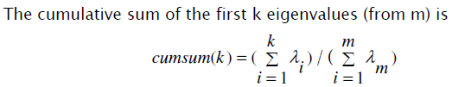
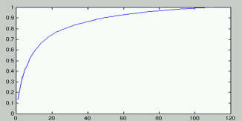
This provides an insight on how many eigenvalues(x axis) should be retained to achieve a certain % of variation(y axis)

6.8 Properties of PCA
Principal Components can be ordered by decreasing order of "importance" in the following sense:
If you choose to describe the data with only k (k < m) linear combinations of the original variables and yet discard as little information as possible in the process, then these k linear combinations are the first k Principal Components

6.9 Application: Eigenfaces

6.10 MATLAB Commands for PCA
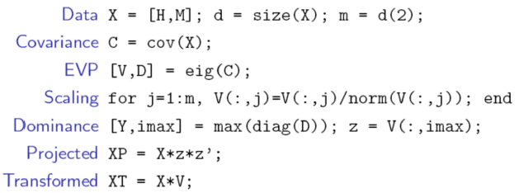

7. Generalised Eigenvectors and Jordan Canonical Form

7.1 Algebraic and Geometric Multiplicity
The algebraic multiplicity (AM) of an eigenvalue is defined as how many times an eigenvalue repeats
The geometric multiplicity (GM) of an eigenvalue is defined as the dimension of the associated eigenspace (i.e. number of linearly independent eigenvectors with that eigenvalue)

7.2 Defective eigenvalue
If GM<AM for any eigenvalue, there will be insufficient eigenvectors to span the entire space (so diagonalisation is not possible).An eigenvalue whose geometric multiplicity is less than its algebraic multiplicity is called a defective eigenvalue
A square matrix (n x n) that has at least one defective eigenvalue is a defective matrix, which cannot be diagonalised
Eigenvectors of different eigenvalues are always linearly independent
Real symmetric matrices, GM = AM

Example
A has eigenvalues 1 (AM=2) and 2(AM=1)
Eigenvectors can be (1,0,0) (0,1,1)(geometric multiplicity=2) [they are the only two independent eigenvectors with the simplest form. Any other eigenvectors such as (1, 1, 1) can be expressed linearly by these two eigenvectors]
Eigenvector :( 1, 1, 0) (geometric multiplicity=1)
Those three eigenvectors can be shown to be linearly independent.
It concludes that A is a non-defective matrix

7.3 Generalised eigenvector
Example
For a defective matrix
(eigenvalue 1 with a AM of 3)
There is only one eigenvector corresponding to 1 (GM=1), but we can find two generalised eigenvector x₂, x₃such that:
or or
And we have

The generalised vectors are linearly independent, but they are not necessarily orthogonal

Generalised vector chains
For example, x3 will get back to the null space (origin) by multiplying $A-λI$ two times. As shown in the graph, x3 is two chains away from the origin.
GM = number of chains; AM = total length of chains
In this case, the chain number is 1, i.e. there is 1 chain that connects all x1, x2, x3 together.

7.4 Jordan Block

7.4.1 Jordan Canonical form
where X is a set of eigenvectors and generalised eigenvectors X={x1, x2,…,}
(J_{k} is one Jordan block)

Jordan block is an upper triangular matrix with the eigenvalue on the diagonal, and a “1” above the diagonal for each generalised eigenvector position
For the example above, the Jordan block is
$$\left[\begin{matrix}1 & 1 & 0 \\ 0 & 1 & 1 \\ 0 & 0 & 1\end{matrix}\right]$$
Square Matrix A can be decomposed as, given X is invertible
$$A=XJX^{-1}$$
This is called Jordan decomposition.

Example
How many Jordan blocks in J?
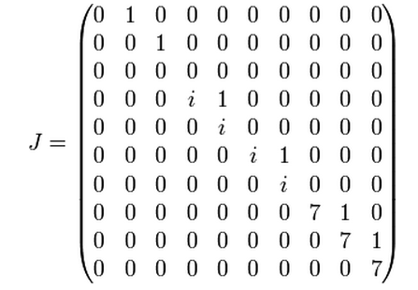
J has one 3*3 block with eigenvalue 1, two 2*2 blocks with eigenvalue the imaginary unit and a 3*3 block with eigenvalue 7

7.4.2 Rules for Jordan J matrix
- GM = number of chain for certain $λ$ = number of eigenvectors = number of Jordan blocks
- AM= total length of all the chains for$λ$ = the size of the Jordan Matrix
- the size of the Jordan block = length of the chain

Example
One chain connects v1 and v2 to zero; the other one chains u to zero.

- Jordan Blocks are numerically unstable to compute (prone to round-up errors).

8. Orthogonalisation and Schur Decomposition

8.1 Complex matrices

Normal Matrices
- All Hermitian, skew-Hermitian, Unitary matrices (Q^{H}Q=QQ^{H}=I) are normal.
- Normal matrices (A^{H}A=AA^{H}) always have a complete set of orthogonal eigenvectors, therefore they are all diagonalizable

8.2 Orthogonality
Orthogonal basis are more stable. Their properties like Q^{T}=Q⁻¹preserves of lengths and angles which leads to no magnification of errors
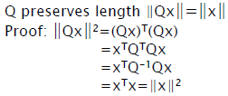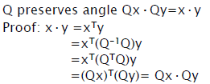
(Q is orthogonal)

8.3 Orthogonal set
Space spanning
A set of vectors S =(v1, v2, . . . , vk ) span some subspace W if every vector in W can be written as a linear combination of the vectors in S
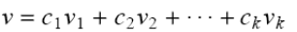

A set of vectors S =(v 1, ..., vk) is said to be a basis for a vector space W if
(1) vj are linearly independent
(2) S spans W

Orthogonal set
A set of vectors is called an orthogonal set if all pairs in the set are orthogonal (dot product = 0). All vectors in the orthogonal set are linearly independent

Any vector can be represented by orthogonal basis
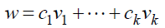
with the coefficient given by
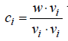

8.4 Orthogonal Projections
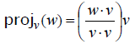
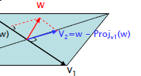
We project w to v1, and we subtract off the projection from the vector w, then we have a new vector that is orthogonal to the basis vector

Given a set of non-orthogonal unit vectors a1, a2, …, we wish to construct a set of orthonormal vectors q1,q2,…
At the j^{th} step we wish to find a unit vector q_{j} that is orthogonal to q₁,q₂,… ,q_{j-1}
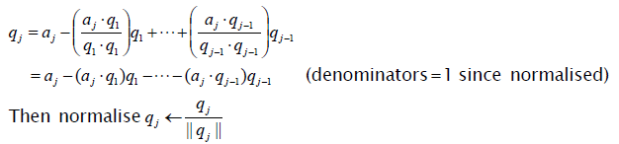

8.5 Gram-Schmidt Orthogonalisation
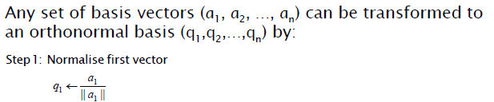
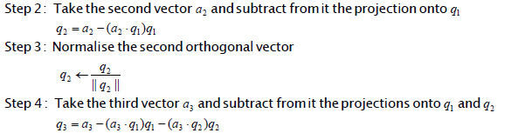
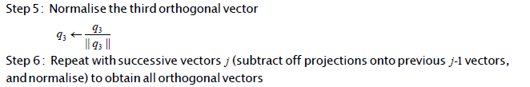
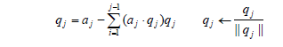

8.6 Schur Decomposition
Gram-Schmidt Orthogonalisation leads to decomposition
$$A=QR$$
where R is calculated by $R=Q^{-1}A=Q^{T}A$. R is an upper triangular matrix

The Jordan Canonical Form can be reorganised into Schur Decomposition, for a square matrix
$$A=QSQ^{H}$$
where Q is a unitary matrix (with QQ^{H}=I=Q^{H}Q) and S is upper triangular with the eigenvalues of A appearing on the diagonal of S.

The Schur Decomposition is more numerically stable than Jordan Canonical Form, because normal matrices (Q) preserve lengths, norms, angles, and so they don’t magnify errors in calculations

9. Singular Value Decomposition (SVD)

9.1 Properties of an m x n matrix
- A tall matrix A (m > n) represents the coefficients of an over-determined system of linear equations
- A wide matrix A (n > m) represents the coefficients of an under-determined system of linear equations
- For m ≠ n, the rank of the matrix ≤ min(m,n)
-The matrix product A^{T}A is square (n x n) and symmetric,and AA^{T} is square (m x m) and symmetric

9.2 Singular values
Singular values are the positive square roots of the eigenvalues of A^{T}A
The singular vectors (u and v) come in a pair for each singular value$σ$, such that
- If A is real symmetric matrix with non-negative eigenvalues, then eigenvalues are equal to singular values

9.2.1 Geometric interpretation
The v in n-dimension space stretched by A represent a u vector scaled by theta in m-dimension space.

9.3 Singular Value Decomposition
A rectangular matrix A can be decomposed by
$$A=UΣV^{T}$$
with U and V^{T} being the matrices for singular vectors and $Σ$consisting of the singular value on its diagonal.
$$Σ=diag\{σ_{1}, σ_{2},…σ_{n}\}$$
Note that $σ_{1}$ is the greatest.
Also note, the vector U and V^{T} are orthogonal matrices

9.3.1 Reduced SVD (or economy SVD)
We can group the non-zero singular values in a square block D and 0 values for the rest of the elements. This will ease the calculation.
The reduced version

[a diagonal rectangular matrix is one start from the top-left but it does not finish at the bottom-right]

9.4 SVD Calculations
For a rectangular matrix (m*n)
- The n x n matrix A^{T}A is square and symmetric, and its eigenvectors form the columns of the n x n matrix V
- The m x m matrix AA^{T} is square and symmetric, and its eigenvectors form the columns of the m x m matrix U
- The m x n rectangular matrix $Σ$ (made up of the square matrix D, and a zero block) stores the singular values down the diagonal
- The singular values are the square roots of the eigenvalues of A^{T}A or AA^{T}

Another important equation is
by which we can find U

9.5 Four Fundamental Subspaces of A via SVD[link to more]

9.5.1 Subspaces
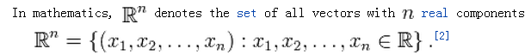
Geometrically, a subspace of R^{n} is simply a flat through the origin

Example
There are four different types of subspaces in R³
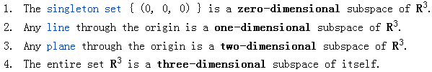
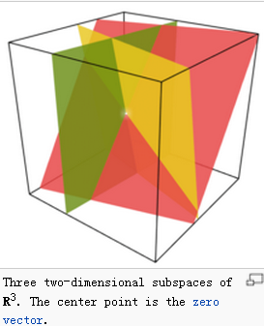

9.5.2 Four fundamental subspaces
There are four fundamental subspaces of a matrix A row(A), col(A), null(A), null(A^{T})

Column space
The column space, C(A) of a matrix (or the range of a matrix) is the set of all possible linear combinations of its linearly independent column vectors. The dimension of the column space is the rank of the matrix.

Example
For matrix A
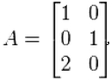
A linear combination of the column vectors of the form
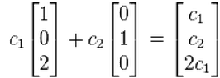
The column space is the set of vectors (x, y, z)∈ R³ satisfying the equation z = 2x

Any linear combination of the column vectors of a matrix A can be written as the product of A with a column vector
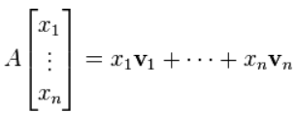
Therefore, every the column space of A consists of all possible products Ax, for x ∈ Rn

Null space
The kernel or null space (also null space) of a matrix A is the set of all vectors x for which Ax = 0

Summary
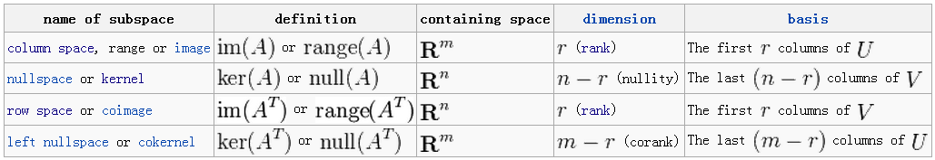

9.5.3 Solvability of a non-homogeneous equation
The SVD of the matrix A tells us everything we need to know about these subspaces, and hence the solvability of Ax=b
- The absence of null(A^{T}) indicates that a solution always exists
- The presence of null(A^{T}) indicates that a solution will exist only if b is in the column space of A
- The absence of null(A) indicates that this solution is unique [x in the row space]
- The presence of null(A) indicates infinitely many solutions [x comprises of row space and null space component]

9.5.4 Visual representation

9.6 Rank Theorem
- The rank of a matrix is the dimension of the row and column space
- For any matrix A, rank(A^{T}) = rank(A)
- The nullity of a matrix, nullity(A), is the dimension of its null space (dimension of the solution of Ax=0, which is the same as the number of free variables in the solution)
The Rank Theorem states: If A is an m x n matrix then rank(A)+nullity(A)=n

Example Subspaces Calculations
(R is the row echelon form of A)

The rank is 3
Row space of A : {(1,0,1,0,-1),(0,1,2,0,3),(0,0,0,1,4)}
[Note: row(A) = row(R) since row operations preserve the row space]

Column space of A as: {(1,2,-3,4) ,(1,-1,2,1) ,(1,1,-2,1) }
[Note col(A)≠col(R)]

Null space of A
with 2 vector basis for null(A)

Null space of A^{T}

Finding subspaces via SVD
Col (A) = U₁
Null (A^{T}) = U₂
Row(A) = V₁
Null (A^{T}) = V₂

10. Applications of SVD to data compression and noise filtering

10.1 Matrix Approximation
Using SVD
We can express SVD by sums
($σ_{1}>σ_{2}>…>σ_{r})$
If $σ_{k+1}$ is negligible, we can just keep the first k terms and approximate it by
$σ_{k+1}$ is the error in approximation

Saving memory

10.2 Applications
Noise reduction
We compute SVD for the noisy matrix A, and then discard small singular values of A.

Image compression
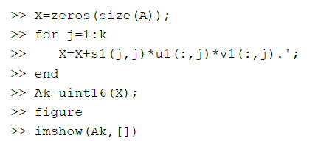

Signal Separation
A signal M with noise N
The main signal part AS can be represented by sum of signals
If the noise is weak, we can differentiate them

10.3 PCA and SVD
To perform PCA, the data needs to be centred and normalised data vector X

PCA requires computing the eigenvalues and eigenvectors of the covariance matrix, which is the product XX⊤, where X is the data matrix.

Constructing covariance from SVD

- PCA does eigenanalysis on mean subtracted covariance matrix (square)
- SVD does eigenanalysis on X^{T}X

11. SVD 2

11.1 Four Fundamental Subspaces
(A: m*n matrix)
Row space range represents all the possible vectors x (=A^{T}b)with a length of n whose bases are the m– r independent rows of A. The m rows of A are also the bases of the row space.
Column space range represents all the possible vectors b (= Ax)with a length of m whose bases are the n – r independent columns of A. The n columns of A are also the bases of the column space.
Null space represents all the vectors x that makes Ax = 0

11.1 Ax = b
N-length vector x can be represented as a vector sum of x_{r} and x_{n}. So A (x_{r} + x_{n}) = b. Since x_{n} is in the null space, Ax_{n} = 0. The operation of Ax_{r} will convert the n-length vector x in row space into am m-length vector b in column space, hence Ax_{r}=b.

11.1.2 Relation to SVD
Col (A)’s bases are the same as U₁
Null (A^{T}) => U₂
Row(A) => V₁
Null (A) => V₂
Note that subspaces do not need to have orthogonal bases like U₁, V₁ which are the orthogonal version which span the same space.

11.1.3 Solvability of Ax = b
Presence of Null (A^{T}) U₂ | a solution will exist only if b is in the column space of A
Absence of Null (A^{T}) U₂ | a solution always exists
Presence of Null (A) V₂ | solution is unique [x in the row space]
Absence of Null (A) V₂ | indicates infinitely many solutions [x= x_{r} + x_{n}]

11.2 SVD Geometry significance
U and V^{T} are orthogonal (rotating effect), and $Σ$ is diagonal (stretch effect)
U => hanger; $Σ$=>stretcher; V=>aligner

11.3 Ill-conditioned matrix
Example

The matrix A is ill-conditioned because small changes in A produce large changes in the solutions x. This happens because its basis vectors are nearly parallel (almost linearly dependent, and det(A) is almost zero). This suggests that round-off errors in A produce huge errors.

Effective rank
SVD provides a way to inspect the nearly-singular values in its stretcher matrix , For singular values
We determine an$ϵ$, such that we keep all the singular values bigger than $ϵ$
The numbers of singular values we kept is the effective rank.

Example
rank (c, 0.1) = 2; rank (c, 0.01) = 3

11.4 2-norm of a matrix

11.4.1 Definition
${\left\|A\right\|}_{2 }$is interpreted as the maximum stretch of a unit vector when A is applied to all the vectors of the unit circle (x)

The vector
$${\left\|Ax\right\|}_{2 }=x^{T}A^{T}Ax$$
If A is orthogonal, ${\left\|Ax\right\|}_{2 }$=1

11.4.2 Calculation
The 2-norm of matrix A,${\left\|A\right\|}_{2 }$, is the square root of the largest eigenvalue of A^{T}A; the largest singular value of A;

11.5 Condition number
The condition number $κ_{2}\left(A\right)$is an error-magnifying factorthat determines the relative size of the error. It is defined as
$$κ_{2}\left(A\right)={\left\|A^{-1}\right\|}_{2 }{\left\|A\right\|}_{2 }=\frac{σ_{max}}{σ_{min}}≥1$$

A large condition number means trouble for most numerical calculations
Orthogonal matrices have a conditional number of 1.

11.6 Error from approximation
If we approximate A
by its k terms
Then it is can be proved
This is the approximation error. It also represents the 2-norm distance between those two matrices.

11.7 Pseudo-inverse of A
The pseudo-inverse, or generalised inverse is for a rectangular A (m x n) or singular square matrix
The pseudo-inverse is an n x m matrix, and the non-zero entries of the diagonal matrix D⁻¹ are the reciprocal of the singular values. It is denoted by “+”

The basic rule is you take inverse of a decomposition of a matrix. The decomposition is the product of several matrices. If you can take inverse of a decomposed matrix, take the inverse; otherwise take its transpose.

For SVD we have
For QR decomposition
$$A^{+}=R^{-1}Q^{T}$$

Applications
- Defining the condition number of a singular or rectangular matrix
- Solving Ax=b, approximately, when a least squares solution is not possible

Properties
The pseudo-inverse does not share all of the properties of a true inverse

13 Least squares approximations and curve fitting

13.1 Curve fitting
Curve fitting is about trying to solve Xc = y for c, where X is a Vandermonde matrix for a polynomial of order p
If there are p+1 data points (x_{i},y_{i}), then this system is solvable (unique vector c), since X is square, full rank, det(X) is non- zero and X is invertible.

Curve fitting seeks to approximate the data by fitting a curve that minimizes the sum of the squared residual errors.
(Residual error is the difference between actual point and the approximated point)

13.2 Least Square approximations
Least Square approximations is used to find c that will minimize ${\left\|Xc-y\right\|}_{2}$ (the residual error)

Residual error measurement
When we fit a line or curve through data, we can measure the residual errors vertically or perpendicularly:
- Vertical is useful for noise in dependent variables
–Perpendicular (Total least squares) is useful for noise in both dependent and independent variables
(Left: vertical; right, perpendicular)

13.3 Least Squares (LLS) Approximation via Normal Equations
We cannot solve Xc = y directly because X is not invertible as it is over-determined
With a₀ and a₁ being variables, the squared residual errors is represented
We want to find a0 and a1 that will minimize Sr, thus
These equations are called normal equations.

It can be proved that the LLS coefficient C can be calculated by
Solution C minimise $\left|Xc-y\right|$ (residual error, not 2-norm). The equation is the matrix form normal equation.

Problems
- The inverse of X^{T}X might not exist
- It is not computationally efficient to invert it for large dimensions
- The matrix X^{T}X may be ill-conditioned

13.4 Geometric Interpretation
We are trying to find a point in the subspace S spanned by the columns of X which is closest to y, which is the projection of y on S
The projection should be orthogonal to every basis of S, which gives us
which is

13.5 LLS via SVD
Numerical problems arise with normal equations. Thus, we can use SVD with pseudo-inverse of X
So the solution to Xc=y is
which is numerically stable and provides an opportunity to remove small singular values

14 Numerical Methods for eigenanalysis (Power method)

14.1 Power method
The normal way to find eigenvalues is not practical when the polynomial’s order is larger than 4. Thus, the power method
The dominant eigenvector v₁ is found by
The Power Method works well when the dominant eigenvalue is clearly dominant (much bigger than others)

14.1.1 Rayleigh Quotient
The eigenvalue corresponding to v₁ is (q_{k} is normalized version of v_{k})
General Steps for Power Method

14.1.2Steps

14.1.3 Related Issues
- If the initial vector x₀ has a zero component in the direction of the dominant eigenvector, then we will not converge
(i.e. for , c₁ = 0)

-The Power method cannot converge if the matrix A is not diagonalisable, or if it doesn’t have a single dominant eigenvalue (AM is not 1)

- Convergence rate depends on how dominant $λ_{1}$ is, if not dominant enough, we use inverse power method (in 14.3)

14.2 Shifted Power Method
Shifted Power Method is used to find non-dominant eigenvalues.
The method bases on the fact: If $λ$ is an eigenvalue of A, then $λ-α$ is an eigenvalue of $A-αI$ for any scalar $α$
Thus, we can perform a shift by subtracting$λ_{1}$off all eigenvalues so $λ_{1}=0$ which becomes non-dominant.
We then use $A-λ_{1}I$ instead of A in the power method, and find its dominant value${ λ}_{2}'$. The actual eigenvalue of A $λ_{2}$is obtained by shifting it back,${ λ}_{2}^{'}+λ_{1}$

14.3 Shifted Inverse Power Method
If $λ$ is an eigenvalue of A, then $1/λ$ is an eigenvalue of A⁻¹ (if the inverse exists), with the same eigenvector
For an eigenvalue of A close to 0, its reciprocal 1/$λ$ is large in magnitude, so 1/$λ$ is dominant. This allows eigenvalue to converge faster.

14.3.1 Steps
- We subtract$α$, to and apply the Power Method to ${(A-αI)}^{-1}$
- We will then rapidly converged to $1/(λ-α)$
- Then we take reciprocal and add $α$to get the eigenvalue

Notes
Calculating ${(A-αI)}^{-1}$ can be tedious. Instead of${ x}_{1}={(A-αI)}^{-1}x_{0}$, we can do Gauss elimination to$\left(A-αI\right)x_{1}=x_{0}$

14.4 Rayleigh Quotient Iteration
And initial eigenvalue based Rayleigh Quotient Iteration is
The iterative process
The difference to the inverse power method is ${(A-λ_{k}I)}^{-1}$ is used instead of ${(A-αI)}^{-1}$ (iterative eigenvalue vs. constant eigenvalue)

15 QR decomposition for eigenanalysis and applications

15.1 QR decomposition via Gram-Schmidt Orthogonalisation
Matrix A can be decomposed by
$$A=QR$$
–Q is m x m, orthogonal, which is found by Gram-Schmidt Orthogonalisation
–R is m x n, upper triangular

For those non-square A

15.2 QR algorithm - Finding eigenvalues/vectors
The eigenvalue of A will be preserved during QR decomposition. A_{k} will converge to an upper-triangular matrix and the (approximated) eigenvalues are on its diagonal. These eigenvalues are the same as those in A, A₁, A₂

The essence of the iteration is that each iteration effectively transfers some “mass” from the lower triangular part of an Ak to the upper triangular part.
As k→∞ we approach the Schur Decomposition A_{k}S (as in Schur Decomposition)

After finding the eigenvalues, we need to find the eigenvectors, which is accomplished by using power methods by substituting $α$ or $λ_{k}$ with the approximated eigenvalues.
Analytical methods cannot be used to find eigenvectors because the eigenvalues found in QR iteration are not exact.

15.3 Solution to Ax=b by QR
With
x is found through back substitution (because R1 is upper triangular)

On such purpose, QR decomposition is numerically stable than LU decomposition, but requires more computation

15.4 Solution to LLS by QR
The normal equations can be written using A=QR
(in this way, we have avoided calculating (A^{T}A)⁻¹)
QR is more accurate and expansive than normal equations, less so than SVD;

16 Overview of optimisation

16.1 Maxima, Minima and Convex

16.1.1 Local versus global minima
A global minimum is the minimum of a set of local minima (i.e. it is a local minimum in its neighbourhood, but also the minimal of all local minima)

16.1.2 Convexity - domains
A domain D∈R^{n} is convex if the straight line segment connecting any two points in D lies entirely inside D.
Mathematically, for any two points x∈D and y∈D, if we have αx+(1-α)y ∈D for all α ∈[0,1], then domain D is convex.

16.1.3 Convexity - functions

(A convex function)

- Any local minimum of a convex objective function is also its global minimum
- Any local maximum of a concave objective function is also its global maximum

16.2 Quadratic Forms
A quadratic function can be written as
f(x) can be classified by
The classes are determined by eigenvalues of A

Example
So f (0, 0, 0) = 0 is the minimum.

16.3 Analytical approach to optimisation

16.3.1 2nd derivative test

The sufficient conditions for a point x* to be a local optimum of f(x) are
[1st derivative test]
And
[2nd derivative test]

16.3.2 Limitations in analytical approaches

17. Unconstrained optimisation

17.1 Iterative algorithms
The general iterative algorithms is
Stop if iterations exceed max, or computation time exceeds max, or stop if no change in x_{k}, or gradient is close to zero

There are two commonly used methods: Steepest Descent method and Newton method.

17.2 Steepest Descent method

17.2.1 Direction vector d
The direction vector for step k is given by
which guarantees

17.2.2 Step size a
We usually find first derivative and set it to zero to find a. This is called line search.

17.2.3 a and d for quadratic functions
For a quadratic function
The direction vector d is
The step size a is

17.2.4 Convergence rate of Steepest Descent for Quadratic functions
For
If the ratio is small, then convergence will be faster.

Fast convergence and slow convergence
Fast: each steepest descent direction (gradient) is orthogonal to the contour lines
Slow: The steepest descent search zig-zags down

17.2.5 Non-quadratic functions
The steepest descent method does not have a good performance for non-quadratic functions, as linear search cannot be used and step sizes are not easily determined.

17.3 Newton’s method
Direction vector and step size is given by
The product is used for iterative method

Features
The convergence rate is higher but it is less reliable unless the starting point is close to a minimum, as the Hessian matrix may not be positive definite unless we are in vicinity of a local minimum

18. Constrained optimisation

18.1 Constrained optimisation overview
Example
We can converter it into a unconstrained problem
The minimum of this function will minimise both f and the constraint term

Three approaches are generally used
- Penalty Functions
- Elimination of Variables
- Lagrange Multipliers

18.2 Penalty Functions
The constraint is added as some function which penalises the new objective function if the constraints are violated
There are two types of constraints:
- Hard constraints: must never be violated during the search (e.g. x²<0)
- Soft constraints: can be violated during the search as long as the final solution is feasible

Example 1 Quadratic penalty function
We can use a quadratic penalty function for the constraint that imposes a quadratic penalty if the constraint is violated, but no penalty if it is satisfied. Thus,
If the constraint is positive (violated), the penalty term will be positive.
If the constraint is negative, the penalty term will be zero.

The scaling factor μ controls the relative importance of the two terms: small μ means violation of constraint is not important so the penalty is not severe

Example 2 Barrier penalty function
The log function is used to ensure that an initially feasible point never leaves the feasible region (i.e. being positive).
μ is used to counter-balance the log term (minimise the term).

18.2 Elimination of Variables
Used for equality constraints

Example
We construct the constraint in Ax = b.
The particular solution of x is [0 2 2] solved by using the pseudo-inverse x=A⁺b
The rank of A is 2.
Applying SVD, we have
So the homogeneous solutions are linear combinations of this single basis vector
All the possible solutions can be represented by the sum of the particular solution and the null space solution, thus

We now can represent x, y, z with single variable w

18.3 Lagrange multipliers

Generalised Solutions

KKT Conditions
At a local minimum x* for some μ*, the following conditions are satisfied

Example

The gradients of the function and the constraint are
The Lagrangian function is
The KKT condition also requires μ<0. So μ=-0.2635
Substituting back, we have

Second-order Conditions

